|  |  |  |
| --- | --- | --- |
| SCHOOL OF INFORMATION AND TECHNOLOGY | | |
| NAME: Padilla, Arvin | DATE PERFORMED: 22/08/2024 | 50/50 |
| Section: IDC2 | DATE SUBMITTED: 22/08/2024 |

# SYSADM1 – Introduction to File Systems in Windows and Linux

# Requirement:

* A virtual machine running Linux and Windows OS

# Instructions:

**Part A: Windows File System**

1. **Open File Explorer:** Click the File Explorer icon on your desktop or press the Windows key + E.

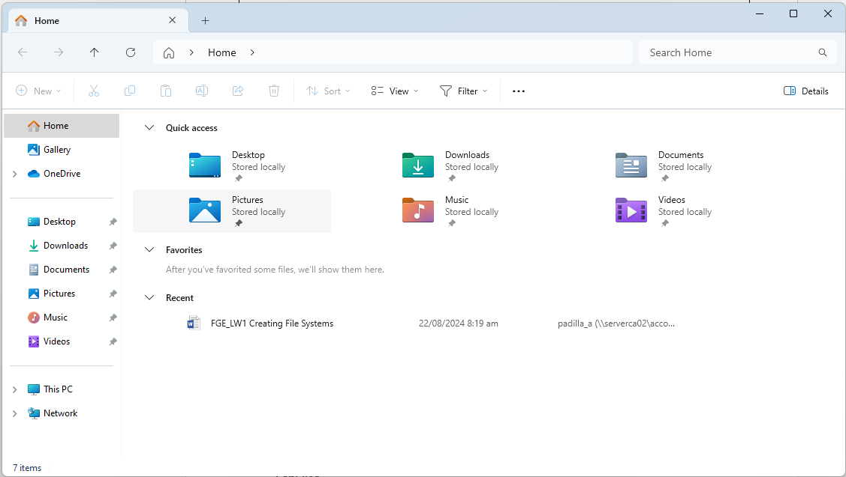

1. **Navigate to your Documents folder:** This is usually the default location for user files.

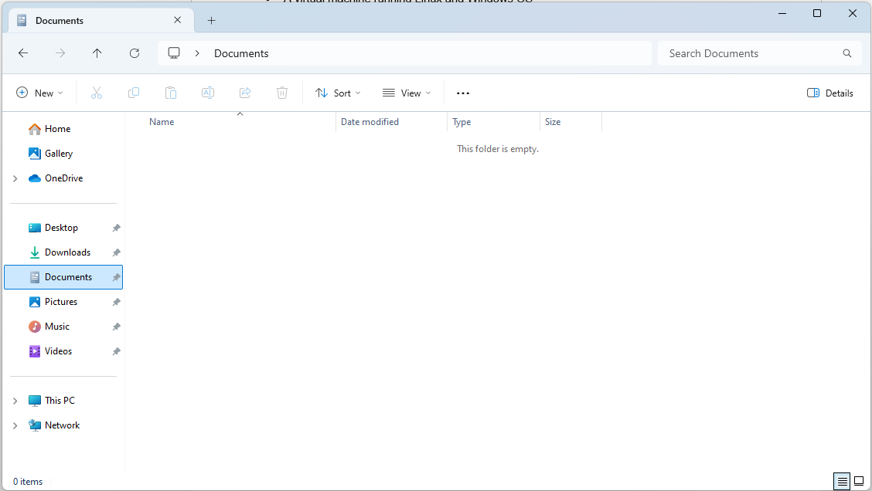

1. **Create a new folder:** Right-click in an empty space, select "New," then "Folder." Name it "Lab1_Windows."

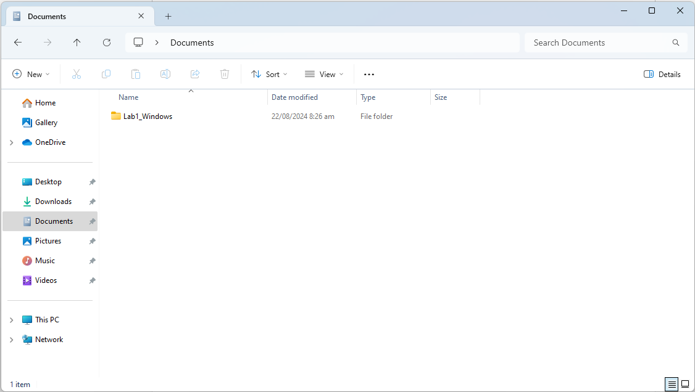

1. **Create a text file:** Right-click in the "Lab1_Windows" folder, select "New," then "Text Document." Rename it to "info.txt."

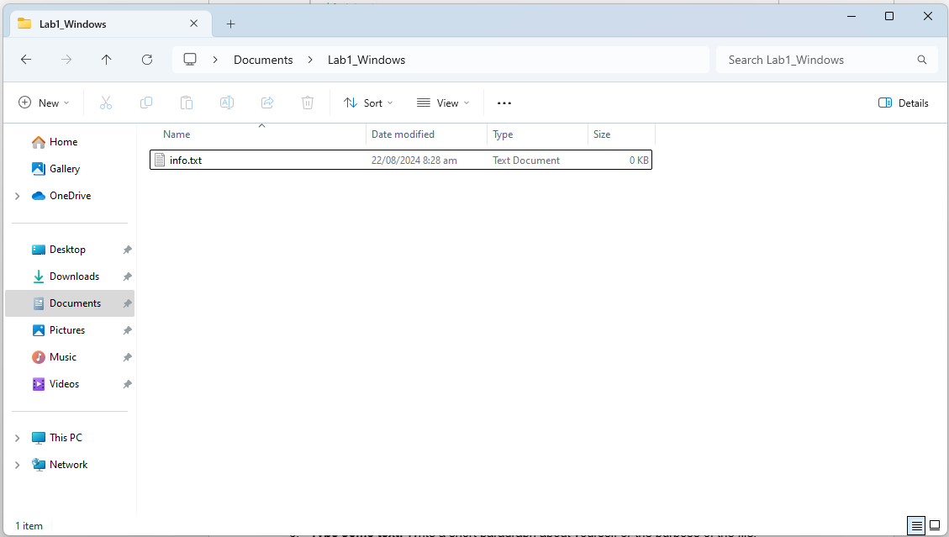

1. **Open the text file:** Double-click the "info.txt" file to open it in Notepad.

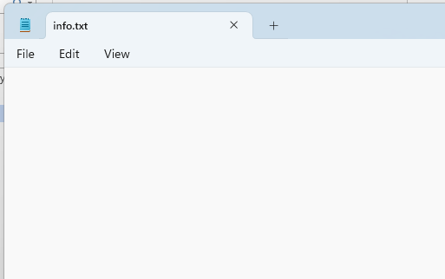

1. **Type some text:** Write a short paragraph about yourself or the purpose of the file.

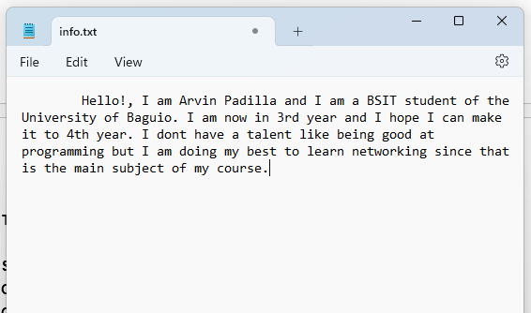

1. **Save the file:** Close the Notepad window and save the changes.

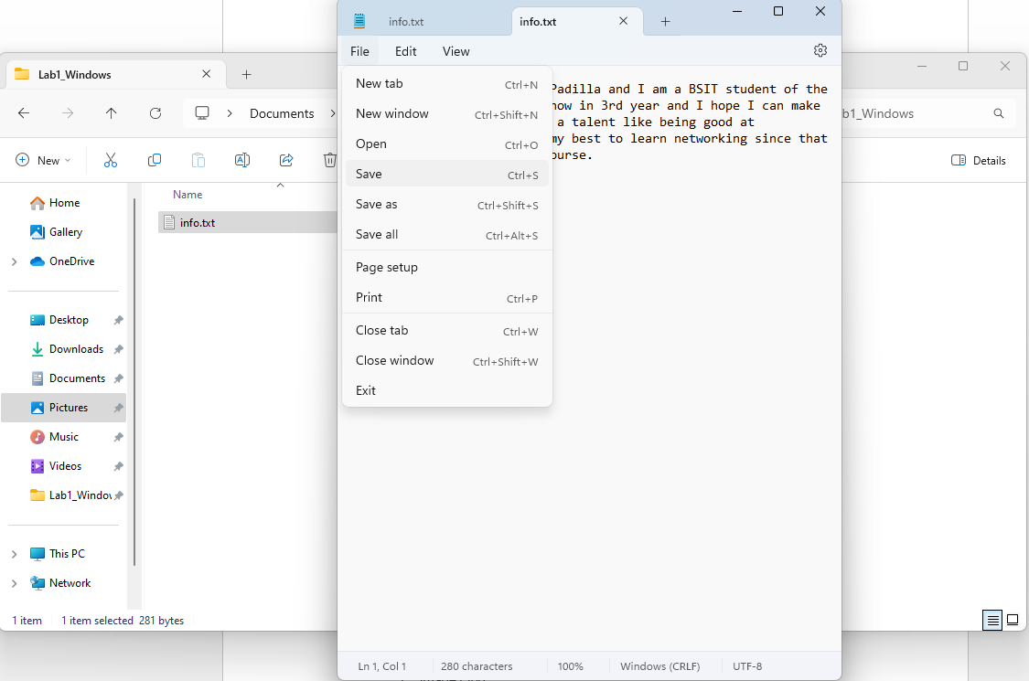

1. **Create a subfolder:** Create a new folder inside "Lab1_Windows" called "Data."

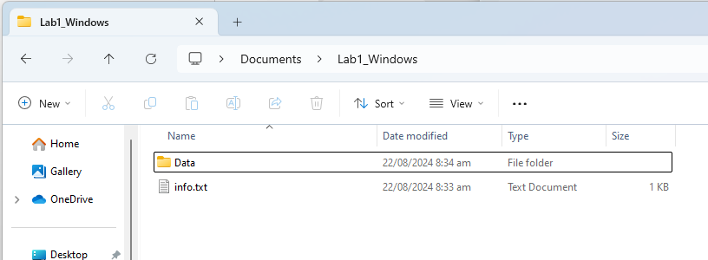

1. **Copy the text file:** Copy the "info.txt" file to the "Data" subfolder.

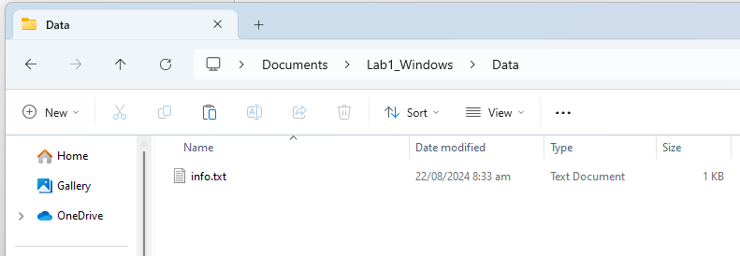

1. **Rename the copied file:** Rename the copied file to "data.txt.

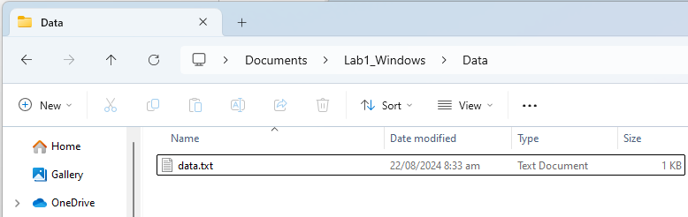

1. Create a folder named "LabFiles" with subfolders for each file type. Use the internet for the resources of the files listed below.



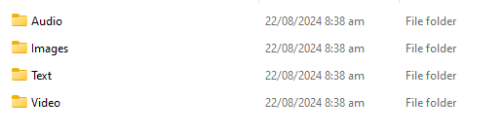

**LabFiles**

* 1. **Text**
     1. large_text.txt
     2. small_text.txt
     3. code.cpp

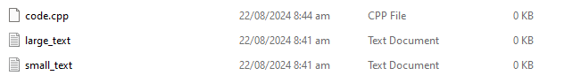

* 1. **Images**
     1. image1.jpg
     2. image2.png
     3. image3.bmp

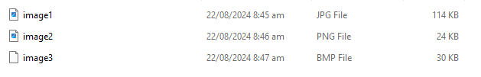

* 1. **Audio**
     1. song.mp3
     2. speech.wav

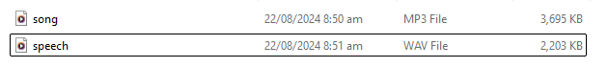

* 1. **Video**
     1. clip.mp4

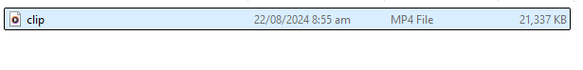

1. **Check file properties:** Right-click on the "info.txt" file and select "Properties." Explore the General, Details, and Security tabs to understand file attributes like creation date, size, and read-only status.

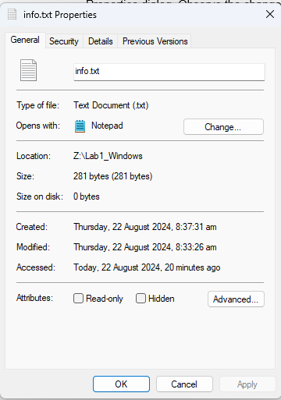 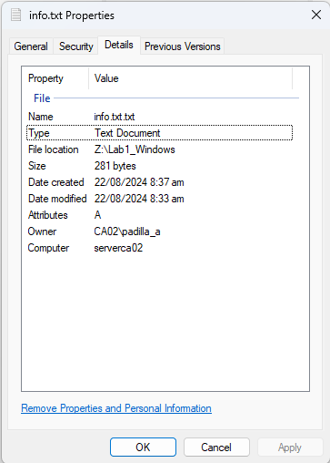 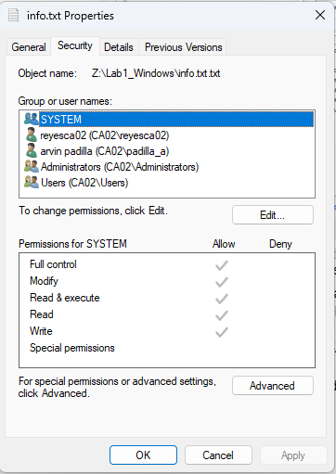

1. **Change file attributes:** Try changing the file attributes (e.g., read-only, hidden) using the Properties dialog. Observe the changes in File Explorer.

I tried changing the txt file to read only and I tried typing and saving it but I can’t. The read only means that you cannot override the file, it will only make another file if you try to.

I also tried the hidden attribute and it hid the file because I could not see it, the only way to see it is to change the options to “See hidden files”.

1. **Share the folder:** Right-click on the "Lab1_Windows" folder, select "Properties," and then the "Sharing" tab. Share the folder with a specific user or group, setting appropriate permissions (e.g., Read, Write, Full control)

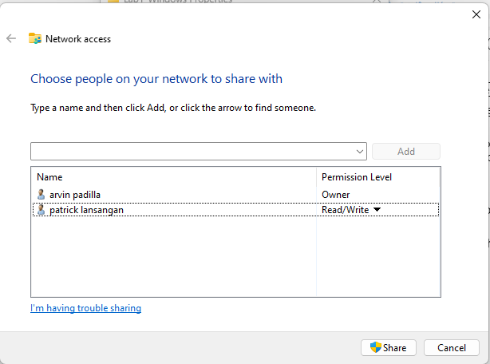 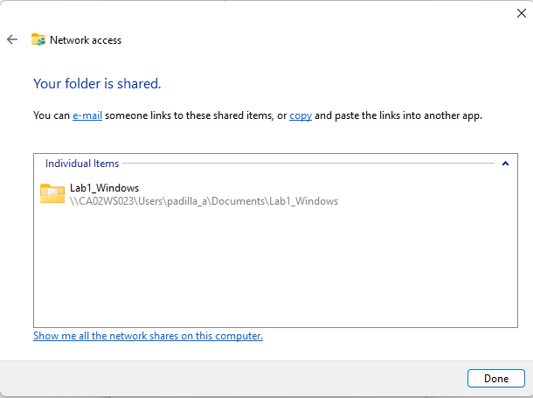

1. **Create an archive:** Use WinRAR or 7-Zip to create a compressed archive of the "Lab1_Windows" folder.



1. **Extract an archive:** Create a new folder, then extract the created archive into it.

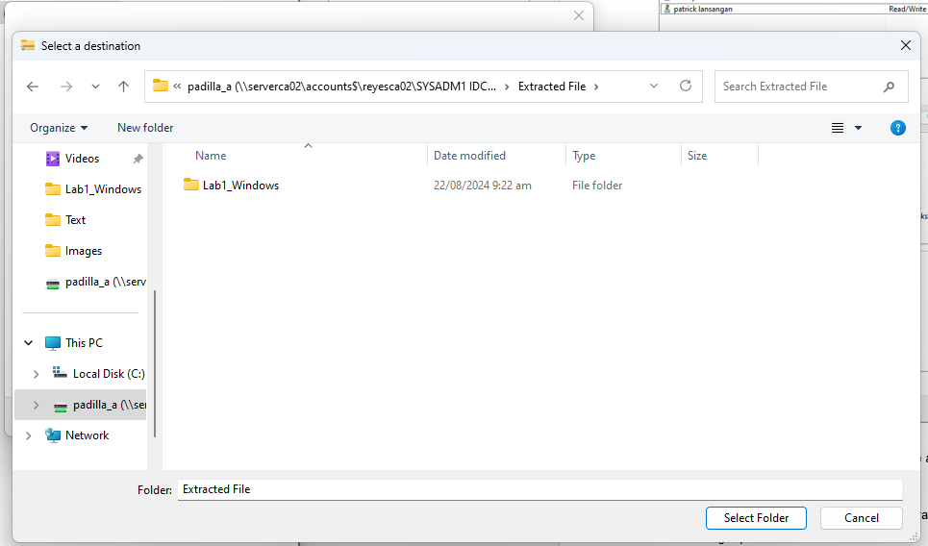

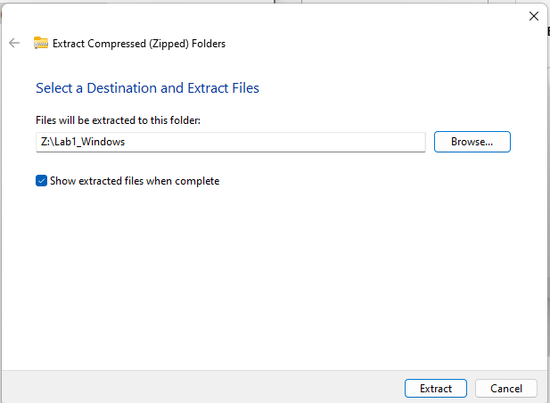

Part B. Create a log report structure

|  |  |  |  |
| --- | --- | --- | --- |
| **Objective:** Complete a series of tasks related to file and folder management in the Windows File System. | | | |
| Steps to complete: | Action Taken: | Outcome: | Issues encountered/Observations: |
| Open File Explorer | Opened File Explorer using the desktop icon and Windows key + E. | Successful. | No issues |
| Navigate to Documents Folder | Accessed the Documents folder. | Successful. | No issues |
| Create a New Folder | Created a folder named "Lab1_Windows" in Documents. | Successful. | No issues |
| Create a Text File | Created a text file named "info.txt" inside "Lab1_Windows." | Successful. | No issues |
| Open the Text File | Opened "info.txt" in Notepad. | Successful. | No issues |
| Type Some Text | Wrote a short paragraph in the text file. | Successful. | No issues |
| Save the File | Closed Notepad, saving the changes to "info.txt." | Successful. | No issues |
| Create a Subfolder | Created a subfolder named "Data" inside "Lab1_Windows." | Successful. | No issues |
| Copy the Text File | Copied "info.txt" to the "Data" subfolder. | Successful. | No issues |
| Rename the Copied File | Renamed the copied file to "data.txt." | Successful. | No issues |
| Create a Folder Named "LabFiles" | Created "LabFiles" folder with the following subfolders:  Text: large_text.txt, small_text.txt, code.cpp  Images: image1.jpg, image2.png, image3.bmp  Audio: song.mp3, speech.wav  Video: clip.mp4 | Successful. Files sourced from the internet as per instructions. | No issues |
| Check File Properties | Checked properties of "info.txt."  **General Tab**: Verified file attributes like creation date and size.  **Details Tab**: Reviewed file details.  **Security Tab**: Inspected security settings. | Successful. | No issues |
| Change File Attributes | Changed "info.txt" to read-only and hidden attributes. | Observations noted. | **Read-Only**: Unable to edit or overwrite; new file must be created for changes.  **Hidden**: File was hidden and only visible by adjusting File Explorer settings. |
| Share the Folder | Shared "Lab1_Windows" folder. | Successful.  Sharing Tab: Set permissions (e.g., Read, Write, Full control) for specific user/group. | No issues |
| Create an Archive | Created a compressed archive of the "Lab1_Windows" folder using [WinRAR/7-Zip]. | Successful. | No issues |
| Extract an Archive | Extracted the created archive into a new folder. | Successful. | Compression and Extraction: Archive creation and extraction processes were successfully completed, illustrating the use of file compression tools. |
| All specified tasks were completed successfully, demonstrating effective file and folder management skills. | | | |